There are 3 key ownership roles in process documentation; process owner, documentation custodian, and technical writer. In some cases, the same person may play all three roles.

Process Owner: The process owner is responsible for the overall design and management of a particular business process. This includes identifying the goals and objectives of the process, defining the steps and activities required to achieve those objectives, and establishing performance metrics to measure the success of the process. The process owner is also responsible for ensuring that the process is documented accurately and kept up-to-date.

Documentation Custodian: The documentation custodian is responsible for maintaining the documentation associated with a particular business process. This includes ensuring that the documentation is stored in a secure and accessible location, and that it is properly versioned and updated as needed. The documentation custodian may also be responsible for ensuring that the documentation is properly backed up and archived, so that it can be easily recovered in case of data loss or other issues.

Technical Writer: The technical writer is responsible for creating and updating the documentation associated with a particular business process. This includes writing clear and concise descriptions of each step in the process, creating diagrams or other visual aids to help illustrate the process, and ensuring that the documentation is formatted and organized in a way that is easy to understand and use. The technical writer may also be responsible for collaborating with subject matter experts to ensure that the documentation is accurate and comprehensive.

Key Process Documentation Roles

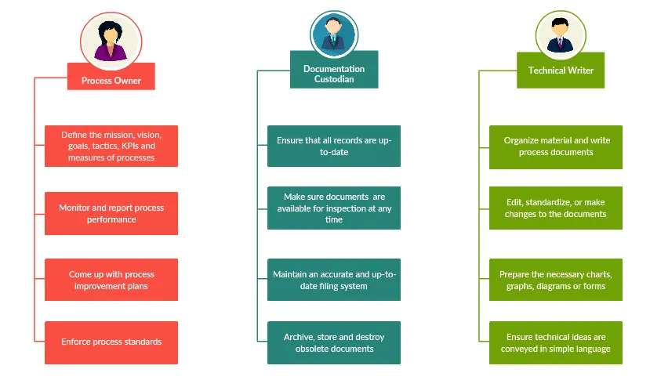

How to Document a Process

Using a step-by-step method to document a process will help you get it done quickly.

Step 1: Identify and Name the Process

Figure out which process you are going to document first. Determine its purpose (why and how the process will benefit the organization) and provide a brief description of the process.

Step 2: Define the Process Scope

Provide a brief description of what is included in the process and what is out of the process scope, or what is not included in it.

Step 3: Explain the Process Boundaries

Where does the process begin and end? What causes it to start? And how do you know when it’s done? Get these boundaries well defined.

Step 4: Identify the Process Outputs

Establish what will be produced by the process or what result the process will achieve once it is completed.

Step 5: Identify the Process Inputs

List down what resources are necessary to carry out each of the process steps.

Step 6: Brainstorm the Process Steps

Gather all information on process steps from start to finish. Either start with what triggers the process or start at the end of the process and track back the steps to the starting point.

The brainstorming session should involve those who are directly responsible for the process tasks or someone with extensive knowledge of it, as they can provide precise data.

Step 7: Organize the Steps Sequentially

Take the list of steps you’ve come up with and put them in a sequential order to create a process flow.

Keep the number of steps to a minimum and if a step includes more than one task, list them under the main step.

Step 8: Describe who is Involved

Decide each individual who will be responsible for the process tasks. Define their roles. Keep in mind to mention their job title rather than their name.

Also be considerate about those who would be referencing the document. Write it in a way that any employee with a reasonable knowledge can read and understand it.

Step 9: Visualize the Process

This is to improve clarity and readability of your documentation. Using a process flowchart , neatly visualize the process steps you’ve identified earlier.

Example process flowchart with swim lanes

Example process flowchart with swim lanes (Click on the template to edit it online)

Step 10: Note down Exceptions to the Normal Process Flow

A business process may not always follow the same flow due to various reasons. Mention these exceptions and what steps will be taken to address them.

Step 11: Add Control Points and Measurements

Identify where risks could occur in the process and add control points to help the process owner when monitoring the process.

Establish measurements to determine the effectiveness of the process and to help improve it.

Step 12: Review and Test the Process

Gather everyone involved and review the process flowchart you’ve mapped. Are there any missing steps? Is everything in order? Once done, test the process and see if you’ve missed anything.

Visualize, analyze, and document your organizational processes. Share and collaborate with your team on identifying process bottlenecks and areas for improvement.